Diploma in Information Technology

Assignment Title: Cloud Project and Video Explainer

Project Name: Cloud Elevate

Name: Muhammad Salman Najam

Student Id: 35279349

Tutor Name: Hena Iqbal

Unit Code: ICT-1711

Unit Name: Introduction to Server Environment and Architecture

DNS: <https://cloudelevate.site/>

IP Address: <http://54.152.122.143>

Introduction

My Project is Cloud Elevate, this documentation outlines the implementation of my Cloud Computing Blog for Small Businesses, developed as part of ICT171 Assignment 2. The blog is hosted on AWS EC2 and designed to provide practical cloud computing resources for non-technical business owners through tutorials, case studies, and cost comparisons, and Ubuntu as the operating system.

Objective

It will demonstrate Iaas proficiency through manual deployment, DNS/SSL configuration, and an automated backup script. The implementation meets all requirements while establishing best practices for secure, scalable cloud hosting. Designed for both academic assessment and real-world utility, the project balances technical rigor with business-friendly accessibility. The platform will serve as a digital hub for learning, interaction, and support in the cloud computing Blog so that new and small businesses can thrive in this new world order. Cloud Elevate cuts cuts through complexity with straightforward tutorial, real-world success stories, and honest cost comparisons- all designed for non-technical business owners. Whether you’re looking to reduce costs, improve efficiency, or prepare growth, we’ll help you navigate the cloud with confidence.

Set up and configuration

I chose Amazon Web Services (AWS) to host my server.

Steps while setting up

1. Login to console: Go to AWS Management Console and login using your credentials.
2. Launch and EC2 instance: Search EC2 after logging in to AWS Management Console and select EC2 services. Then select the launch instance option from EC2 Dashboard.

Choose Ubuntu in AMI options

Select t2.micro instance type which is within the free tier.

Enable both HTTPs ports and SSH port for traffic.

Launch instance.

1. Make your IP Address Static:

Go to EC2 dashboard and select static Ips

Then select your IP address and allocate.

Then associate it with your virtual machine.

1. Connect to your instance:

By using your IP address, connect to your instance and establish an SSH connection.

🡸 click to connect

1. Install Web Server and check if it works by using public IP:



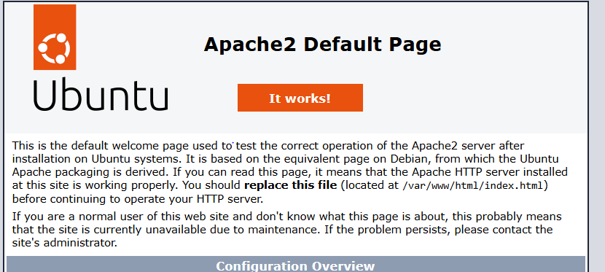

Apache2 is running successfully.

1. Purchase Domain & DNS Setup:

1. Connect Domain to IP Address:

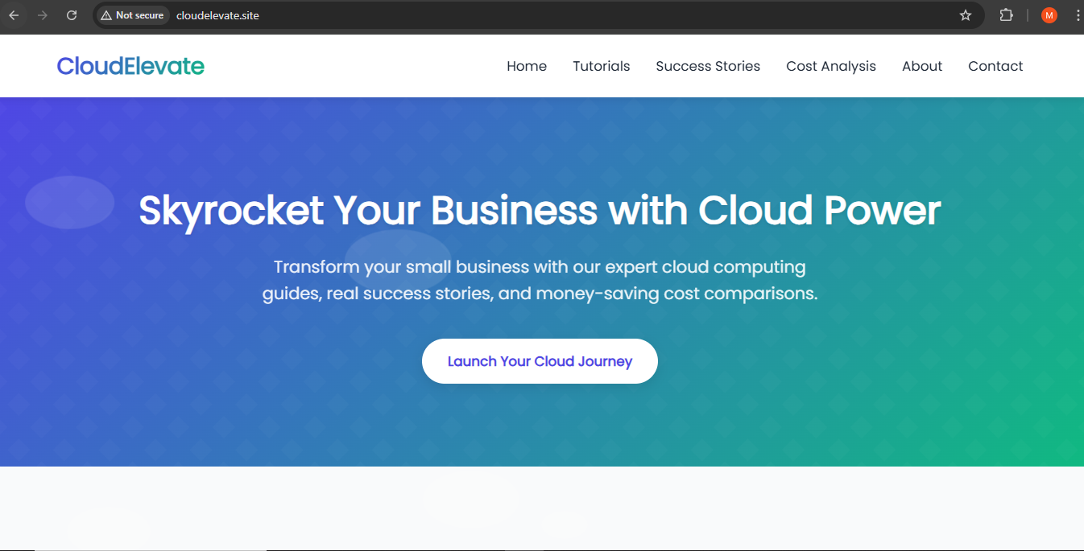Now my website is accessible through my domain and my IP is connected to it.

1. SSL/TCL Configuration:



Now my Website Connection is being secured as you can see on the top search bar.

To write HTML code we can write code as follows:

* cd /var/www/html
* Sudo nano index.html

